Book Knowledge Organiser – The Last Bear
Title of the book: The Last Bear
Date Published: 2022
Author: Hannah Gold
Illustrator: Levi Pinfold
Characters
April | An 11-year-old girl who has a deep relationship with nature.
April’s Dad | A widowed man and scientist with a specialism in measuring weather patterns and climate change.
Bear | A polar bear with a story to tell.
Tor | The son of the captain of the boat that took April and her father to Bear Island
Lisé | Works for the Polar Institute

Context
Ice caps are thick layers of snow and ice covering huge areas. Ice caps have been melting since the beginning of the 19th Century. Scientists think this is because of human activity. Without them the planet will heat up even more.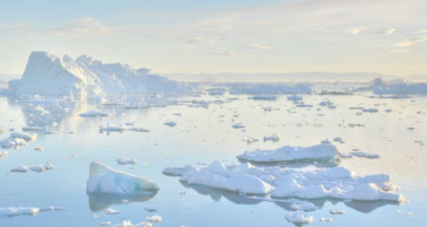
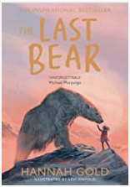
Plot
April’s father’s research takes them to an Arctic outpost for six months to a place called Bear Island. There are no bears left of Bear Island but one night April catches a glimpse of something bear-shaped loping across the horizon.
Setting
A cold, remote island in the Arctic with a small mountain range, inland lakes, small coves and beaches.
Key Themes
Child/animal bonds; hope, courage, climate change
Key Vocabulary
anxious |  | To be nervous or worried.
caution | 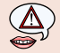 | Taking great care in order to avoid danger.
courage |  | Doing something difficult or dangerous even when afraid.
deafening |  | A very loud noise.
decipher |  | To work out what something says even though it’s difficult to understand.
frustration |  | Upset or angered.
gut-wrenching |  | Extremely shocking or upsetting.
imposing |  | Being bigger in appearance or behaviour.
lurched |  | Moved forwards suddenly.
majestic |  | Beautiful, dignified, impressive.
poised |  | Ready to move at any moment.
summit |  | The top of a mountain.
tentatively | 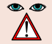 | Do something without confidence
uninhabited | 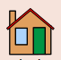 | A place where no one lives.

