Plot
A boy, saved from a sinking ship, returns to the place where he was rescued and forms a relationship with his rescuer.
Setting
Before, during and after the Second World War. Puffin Island, a house on a moor, a boarding school.
Themes
Friendship, hope, overcoming adversity and misfortune
Book Knowledge Organiser – The Puffin Keeper
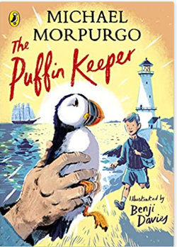
Name of Book: The Puffin Keeper
First Published: 2021
Author: Michael Morpurgo
Illustrator: Benji Davies
Main Characters
Benjamin Postlethwaite | the lighthouse keeper
Allen | a boy – the narrator of the story
Mother | Allen’s French mother
Miss Duval | Allen’s strict and cruel nanny
Grandfather | Allen’s paternal grandfather - a strict man
Grandmother | a quiet, uncaring woman
Mr Mortimer | cruel headmaster at the boarding school
Mr Carter | a kind and encouraging art teacher at the boarding school

Key vocabulary
basked |  | to lie somewhere sunny and enjoy the heat
bemused |  | to be puzzled or confused
choppy |  | a lot of small waves because the wind is blowing
mountainous |  | a mountainous sea is a rough sea
persecutor |  | a person who treats others cruelly or unfairly
quay |  | a platform beside a sea or river
release |  | to set free, be allowed to go
rugged |  | uneven and covered in rocks
schooner |  | a medium-sized sailing ship
tatters |  | badly torn in several places
thundered |  | made a loud, continuous noise

