Name of Book: The Tunnel
Date First Published: 1989
Author & Illustrator: Anthony Browne
Characters
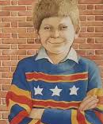 | Jack | Likes playing outside, laughing, shouting, throwing, kicking, playing rough and tumble
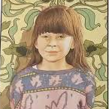 | Rose | Likes staying inside, being on her own, reading and daydreaming

Settings
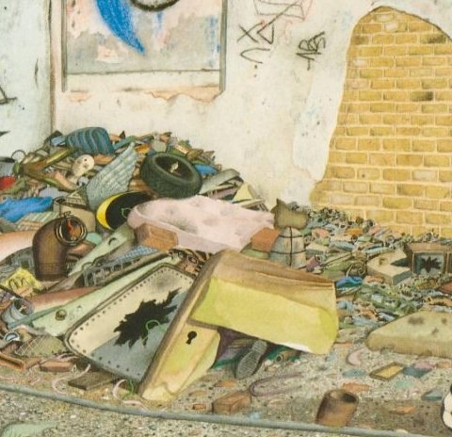 A waste ground
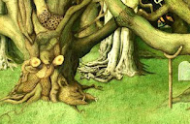 A quiet wood

What sort of story is The Tunnel?
The Tunnel is a portal story is where a character or characters are transported into a new world through a door or window (a portal). They may travel through time, space or both and the new world often has magical or fantasy elements.
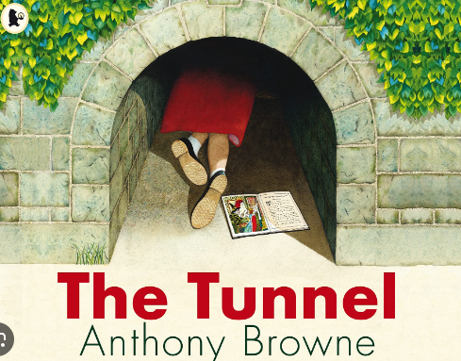
Book Knowledge Organiser –The Tunnel
Key vocabulary
alike |  | two things or people similar to each other
clearing |  | an open space in a forest
crept |  | to move slowly or carefully
damp | 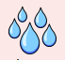 | slightly wet
figure |  | the shape of a person
impatient |  | to get annoyed
soundly | 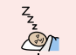 | to sleep soundly is to sleep well
waste |  | rubbish

