Watch Michael Rosen tell the story…
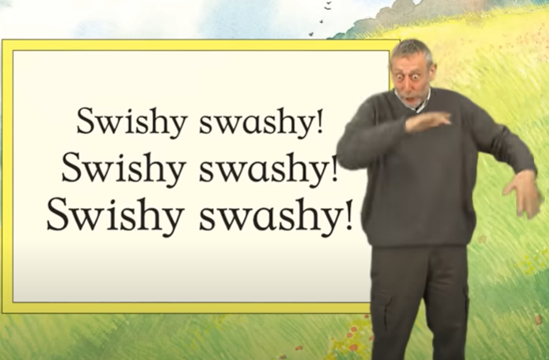
https://www.youtube.com/watch?v=0gyI6ykDwds
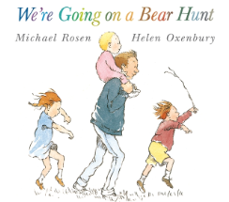
Name of Book: We’re Going on a Bear Hunt
Author: Michael Rosen
Illustrator: Helen Oxenbury

Can you re-tell the story?
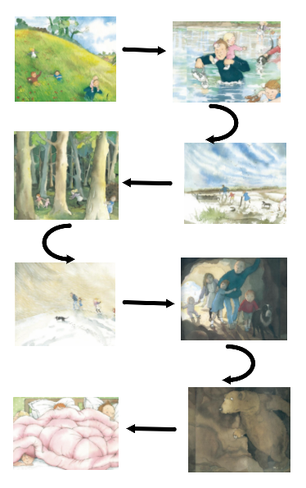

Key Vocabulary

bear |  | hunt | 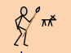
cave |  | mud | 
dark | 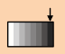 | oozy | 
deep | 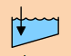 | river | 
forest |  | snow-storm | 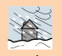
furry |  | shiny | 
gloomy |  | thick | 
goggly |  | wavy | 

Book Knowledge Organiser – We’re Going on a Bear Hunt

