Nursery | Autumn 1
Term 1 | Week 1 |  | Week 2 |  | Week 3 |  | Week 4 |  | Week 5 |  | Week 6 |  | Week 7 |  | Week 8
 | Getting to know you weeks. |  |  |  |  |  | Number 1  Nursery rhymes and books linked to number |  | Number 2  Nursery rhymes and books linked to number |  | Number 3  Nursery rhymes and books linked to number |  | Number 4  Nursery rhymes and books linked to number |  | Number 5  Nursery rhymes and books linked to number
Term 2 | Autumn 2
 | Week 1 |  | Week 2 |  | Week 3 |  | Week 4 |  | Week 5 |  | Week 6 |  | Week 7 |  | Week 8
 | More than Few than and same |  | Explore and build with shapes and objects |  | Explore repeats |  | Hear and say number names |  | Begin to order number |  | I see 1,2 and 3 |  | Join in with repeats
Term 3 | Spring 1
 | Week 1 |  | Week 2 |  | Week 3 |  | Week 4 |  | Week 5 |  | Week 6 |  | Week 7 |  | Week 8
 | January intake children start.  Recap the numbers 1, 2 and 3 |  | Explore position and space |  | Show me 1,2 and 3 |  | Move and label 1, 2 and 3 |  | Explore position and routines |  | Explore first own patterns
Term 4 | Spring 2
 | Week 1 |  | Week 2 |  | Week 3 |  | Week 4 |  | Week 5 |  | Week 6 |  | Week 7 |  | Week 8
 | Take and give 1,2 and 3 |  | Match, talk and pull |  | Talk about dots |  | Compare and sort |  | Lead on own repeats
Term 5 | Summer 1
 | Week 1 |  | Week 2 |  | Week 3 |  | Week 4 |  | Week 5 |  | Week 6 |  | Week 7 |  | Week 8
 | Start to puzzle |  | Making patterns together |  | Make games and actions |  | Show me 5 |  | My own pattern |  | Match sort and compare
Term 6 | Summer 2
 | Week 1 |  | Week 2 |  | Week 3 |  | Week 4 |  | Week 5 |  | Week 6 |  | Week 7 |  | Week 8
Start mastering number | Mastering number week 1 |  | Masting number week 2 |  | Mastering number week 3 |  | Mastering number week 4 |  | Mastering number week 5 |  | Mastering number week 6 |  | Mastering number week 7
Reception |  | Autumn 1
Term 1 |  | Week 1 |  | Week 2 |  | Week 3 |  | Week 4 |  | Week 5 |  | Week 6 |  | Week 7 |  | Week 8
 |  | Getting to know |  |  |  | Talk about measure and pattern  (White Rose) |  | Talk about measure and pattern  (White Rose) |  | Masting number week 1 |  | Mastering number week 2 |  | Mastering number week 3 |  | Mastering number week 4
Term |  | Autumn 2
 |  | Week 1 |  | Week 2 |  | Week 3 |  | Week 4 |  | Week 5 |  | Week 6 |  | Week 7 |  | Week 8
 |  | Mastering number week 5 |  | Mastering number week 6 |  | Mastering number week 7 |  | Mastering number week 8 |  | Mastering number week 10 |  | Mastering number week 11 |  | Circles and triangles  (White Rose) |  | Shapes with 4 sides  (White Rose)
Term |  | Spring 1
 |  | Week 1 |  | Week 2 |  | Week 3 |  | Week 4 |  | Week 5 |  | Week 6 |  | Week 7 |  | Week 8
 |  | Mastering number week 12 |  | Mastering number week 13 |  | Mass and capacity  (White Rose) |  | Mastering number week 14 |  | Mastering number week 15 |  | Explore  3D shapes  (White Rose)
Term |  | Spring 2
 |  | Week 1 |  | Week 2 |  | Week 3 |  | Week 4 |  | Week 5 |  | Week 6 |  | Week 7 |  | Week 8
 |  | Mastering number week 16 |  | Mastering number week 17 |  | Length height and time (White Rose) |  |  |  | Mastering number week 18 |  | Mastering number week 19
Term |  | Summer 1
 |  | Week 1 |  | Week 2 |  | Week 3 |  | Week 4 |  | Week 5 |  | Week 6 |  | Week 7 |  | Week 8
 |  | Manipulate, compose and decompose  (White Rose) |  | Mastering number week 20 |  | Mastering number week 21 |  | Mastering number week 22 |  | Mastering number week 23
Term |  | Summer 2
 |  | Week 1 |  | Week 2 |  | Week 3 |  | Week 4 |  | Week 5 |  | Week 6 |  | Week 7 |  | Week 8
 |  | Mastering number week 24 |  | Mastering number week 25 |  | Mastering number week 26  Rekenrek week |  | Mastering number week 27 |  | Mastering number week 28 |  | Mastering number week 29 |  | Visualise, build  and map  (White rose)

Year 1
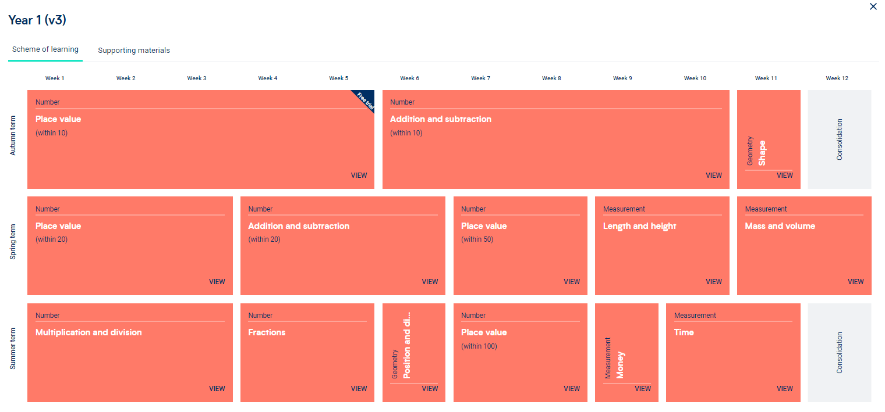

Year 2
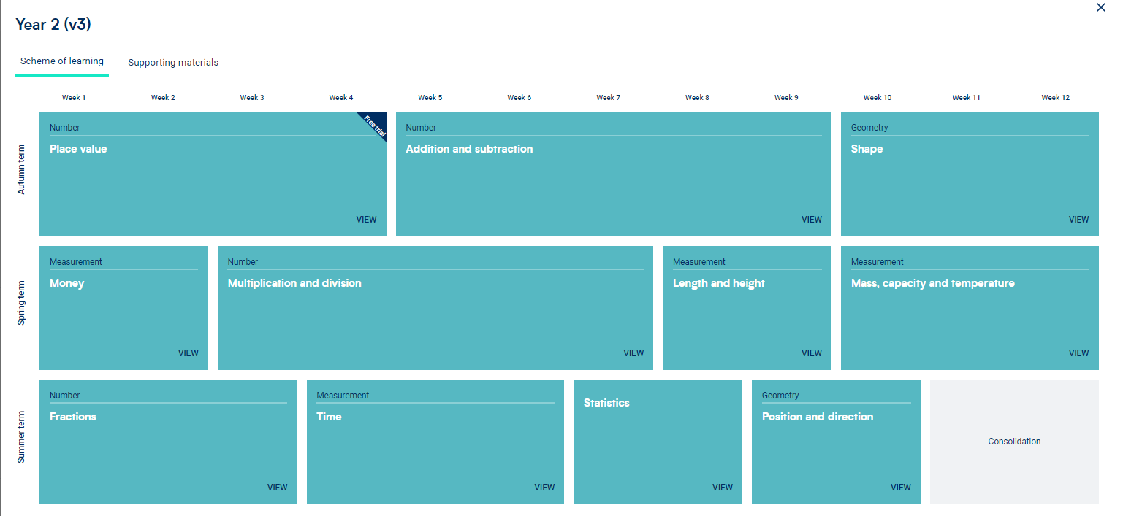

Year 3
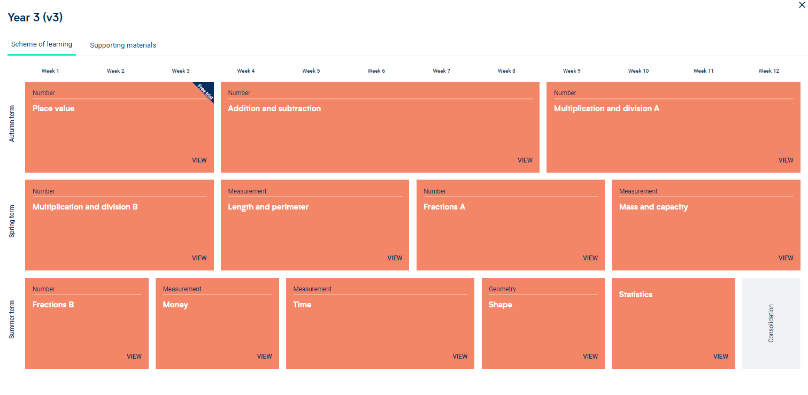

Year 4
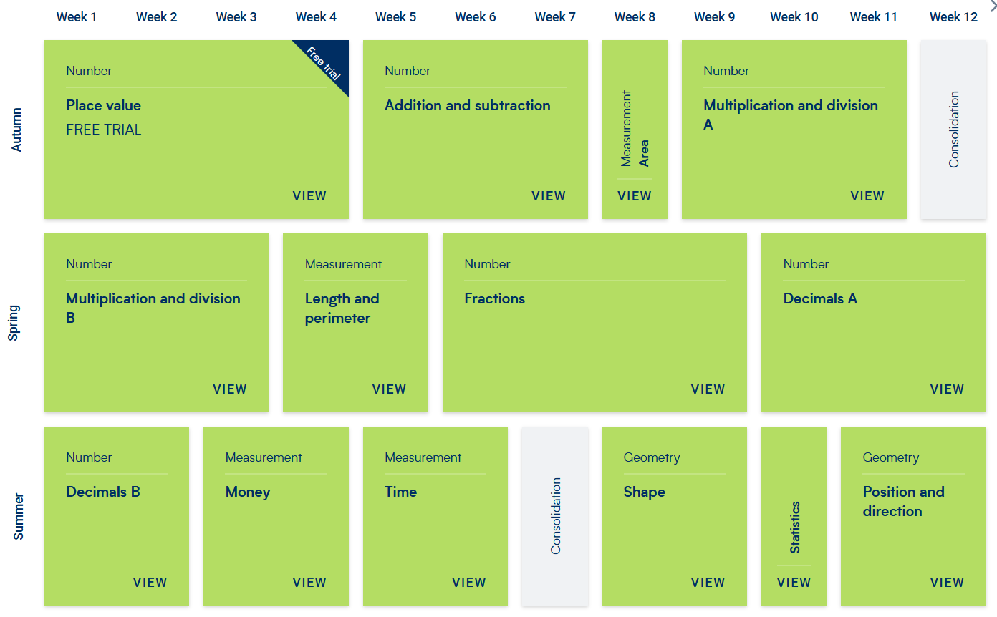

Year 5
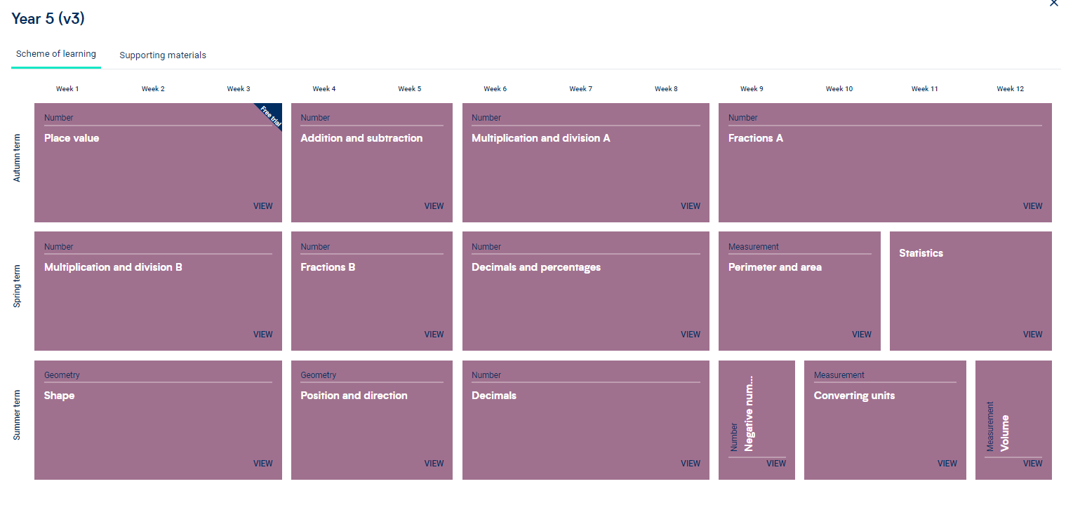

Year 6


