 | Nursery | Reception | Year 1 | Year 2 | Year 3 | Year 4 | Year 5 | Year 6
Autumn 1
Core Text | Pip and Posy: The New Friend  Axel Scheffler  Families, Families, Families  Suzanne Lang & Max Lang | We’re Going On a Bear Hunt  Michael Rosen  Harold and the Purple Crayon  Crockett Johnson | The Three Little Pigs  Mara Alperin & Ag Jatkowska | The Tunnel  Anthony Browne | The Puffin Keeper  Michael Morpurgo | The Explorer  Katherine Rundell | The Last Bear  Hannah Gold | Letter from The Lighthouse  Emma Carroll
 | 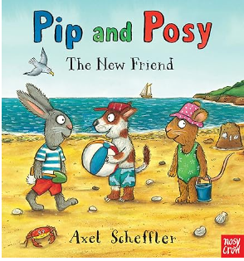  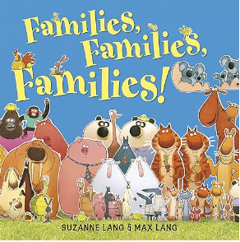 | 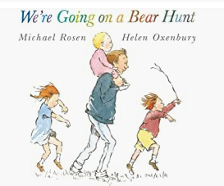  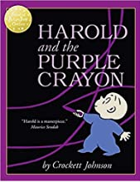 | 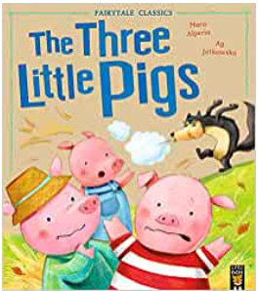 | 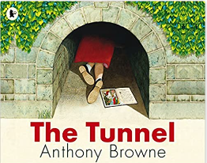 | 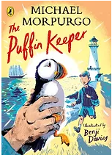 | 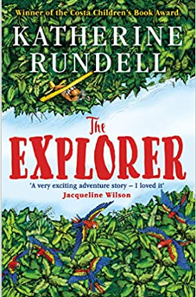 | 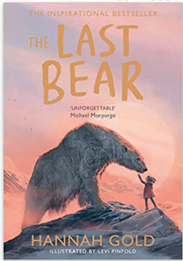 | 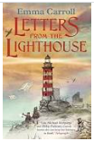
Model Text |  |  | The Three Little Pigs | The Tunnel | Medieval castle description | Explorer extract – raft scene | The Last Bear extract | ‘The Monster’ story set in WWII
Main Writing Outcome | Mark making  Fine and gross motor | Transcription – letter formation  Initial sounds and labels | Transcription  Composition: Sentences in the style of a traditional tale | Transcription  Composition: Section of a  portal story | Transcription  Composition:  Section of narrative with setting focus | Transcription  Composition:  Section of narrative with action focus | Transcription  Composition:  Section of narrative with description focus | Transcription  Composition: Defeating the monster narrative
Audience & Purpose |  | Maps for others to follow | Creating an entertaining ‘Three Little…’ story to share with other Year 1 children. | Creating a portal story book for the school library. | Creating writing for a LKS2 display. | Creating writing for a published book of children’s work. | Showcasing writing to Hannah Gold –messaging her on X. | Writing an historical narrative to entertain people who like Emma Carroll’s books.
Lexile Score  Key Concepts  (See KOs for more detail Y1 – 6) | n/a  Language  Relating stories to selves | n/a  Language  Feelings  Repetition  Related vocab | 490L  Traditional tales  Repeated words and phrases  Simple characters and setting  Related vocab. | 500L  Using pictures and text to tell a narrative  Feelings and emotions  Related vocab. | 540L  Changing characters’ feelings and emotions throughout a lifetime  Related vocab. | 600L  Adventure fiction  Exploring contrasting characters  Related vocab. | Unknown L  Strong female lead character  A story with a topical theme (climate change)  Related vocab. | 700L  Historical fiction  Multiple characters  Narrative with a twist  Related vocab.
Main Class Reader(s) | 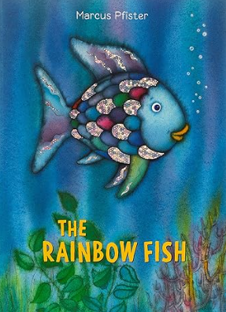  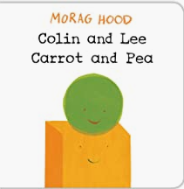  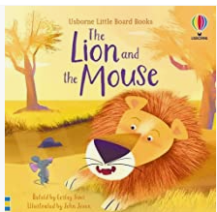 | 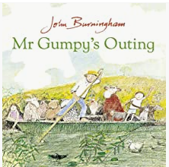  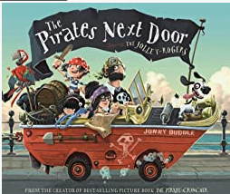  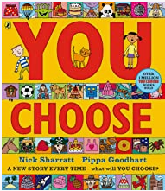 | 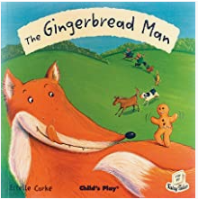  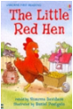  And other traditional tales | 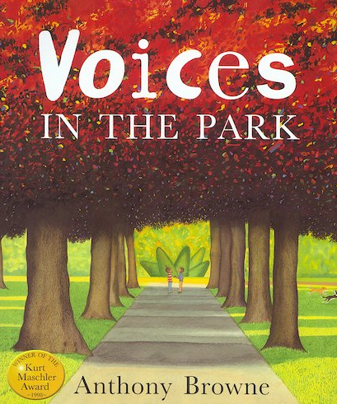  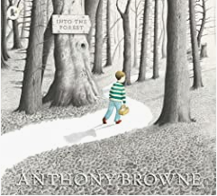  Other Anthony Browne books
Guided Reading  (extracts, articles, online articles, non-fiction books, poetry) | RWI Phonics and fluency |  |  | Decodable text RWI | Stuart Little  E.B. White  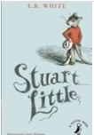  Archaic text | The Lion, The Witch and The Wardrobe  C.S. Lewis  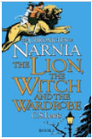  Archaic text | The Storm Keeper’s Island  Catherine Doyle  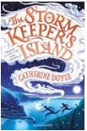  Shift in narrative | The Arrival  Shaun Tan  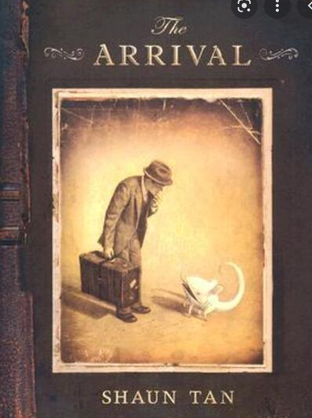  Resistant text  Diversity & inclusion
 |  |  |  | Decodable text RWI | The Role of Women in Ancient Greece  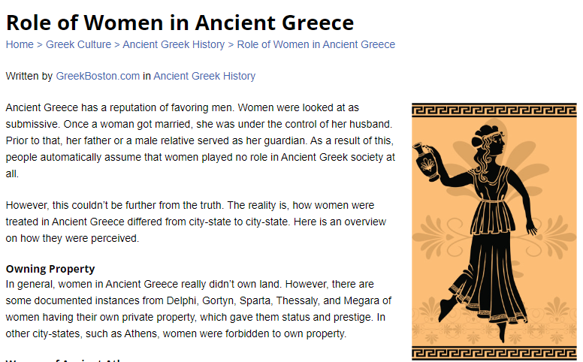  Non-fiction – non-chronological report | Thomas Edison  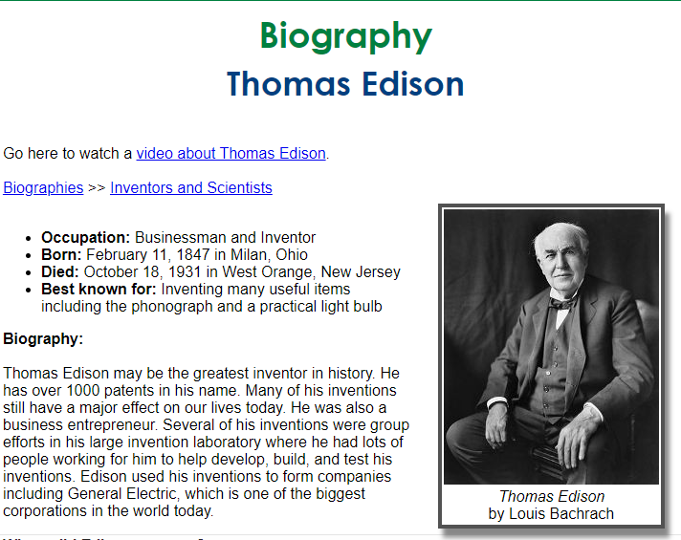  Non-fiction  Biography | Pele  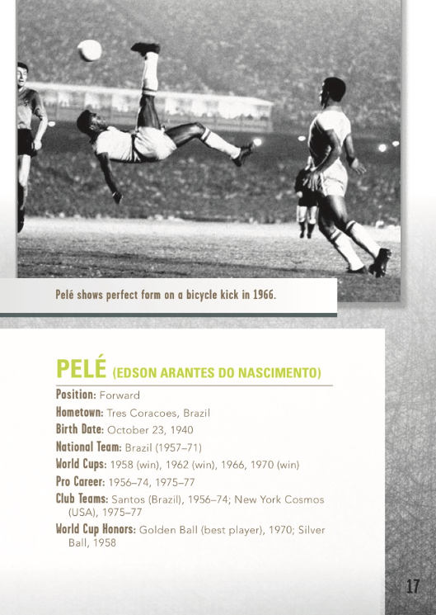  Non-fiction  Biography  Diversity & inclusion | Warring nations of WWII  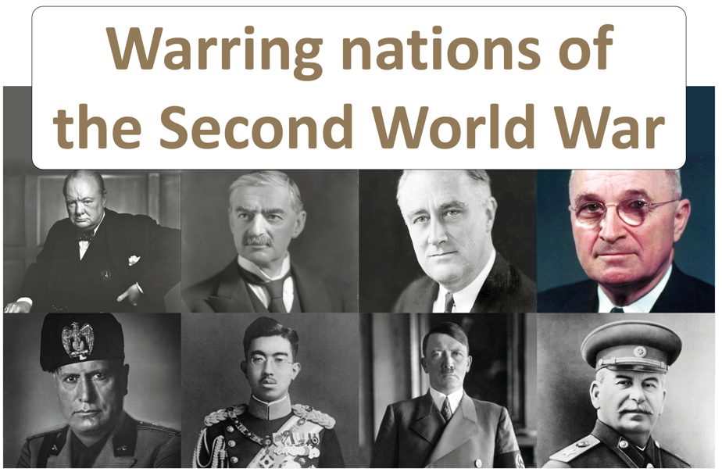  Non-fiction
 |  |  |  | Decodable text RWI | How Far I’ll Go Auli’I Cravalho  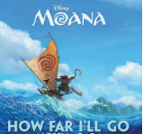  Poetry | Mr Mistofolees T.S. Elliot  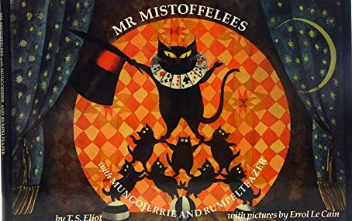  Poetry | The Listeners Walter De La Mare  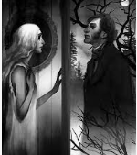  Poetry | World War II Poetry  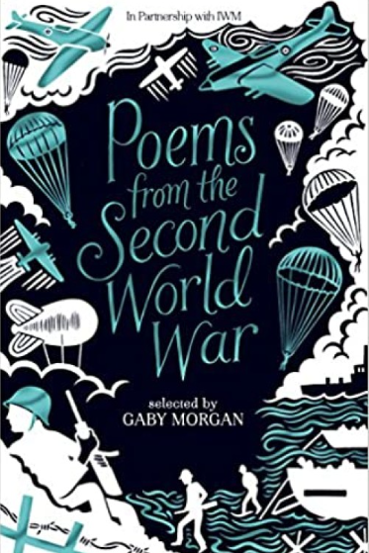
 |  |  |  | Decodable text RWI | The Magic Faraway Tree  Enid Blyton  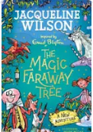  Archaic style | The Witches x 2 weeks  Roald Dahl  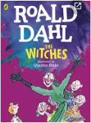  Style of author | Cosmic  Frank Cottrel-Boyce  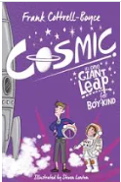  Comedic narrative | Key Events at the beginning of WWII  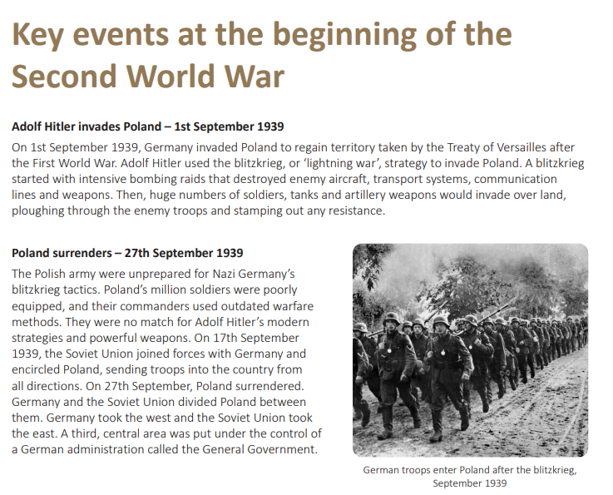  Non-fiction  History link
 |  |  |  | Decodable text RWI | Be Safe on the Internet  Bridget Heos  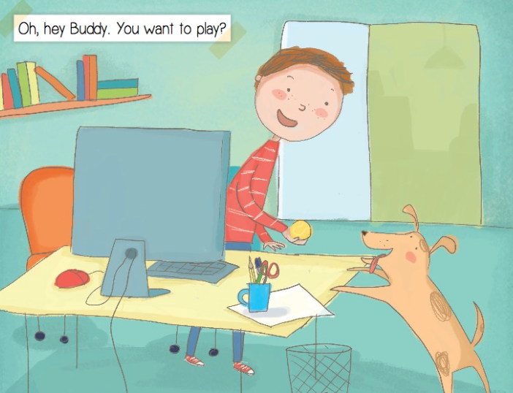  First person – colloquial | Mary Queen of Scots  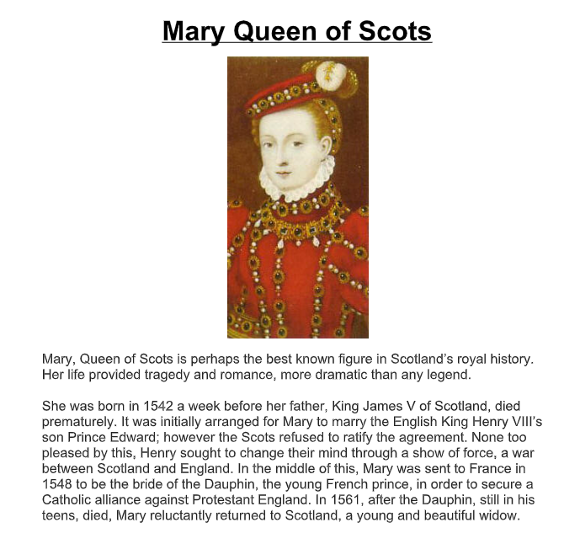  Historical biography | Heston’s Craziest Recipes  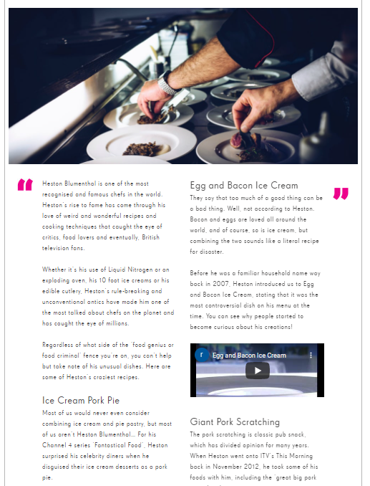  Magazine article | Goodnight Mr Tom  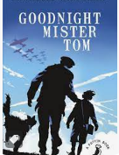  Fiction – dialect in speech
 |  |  |  | Decodable text RWI | Theseus and the Minotaur x 2 weeks  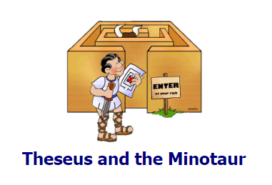  Myths and legends | My Beautiful Birds  Suzanne Del Rizzo  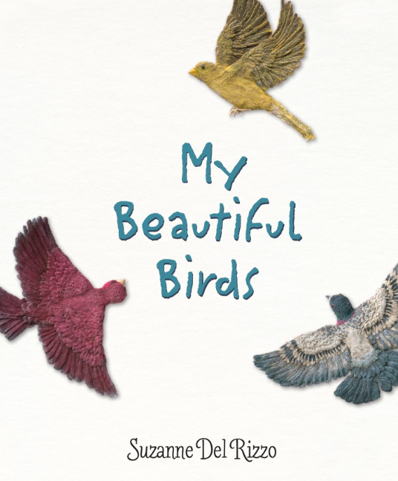  Symbolic meaning | We Refugees x 2 weeks  Benjamin Zephaniah  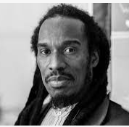  Poetry | Bombs and Blackberries  Julia Donaldson  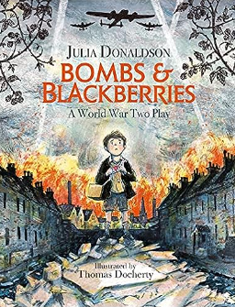  Play script
 | Nursery | Reception | Year 1 | Year 2 | Year 3 | Year 4 | Year 5 | Year 6
Autumn 2
Core Text | Goldilocks and the Three Bears  Ladybird books  The Three Billy Goats Gruff  Ladybird books | Little Red and the Very Hungry Lion Alex T. Smith  Walking Through the Jungle  Julie Lacome | Mega Cars  Christiane Gunzi | Who’s Afraid of the Light?  Anna McGregor | Green: The Story of Life on Our Planet  Nicola Davies | Until I Met Dudley  Roger Mcgough | Bright Stars of Black British History  J T Williams | Everything WWII  Alf Wilkinson
 | 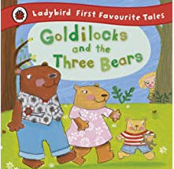  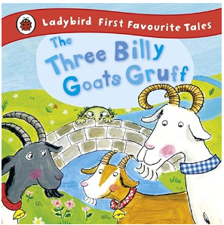 | 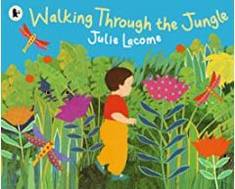  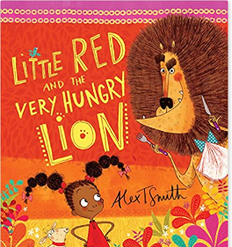 | 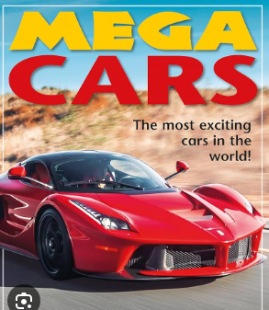 | 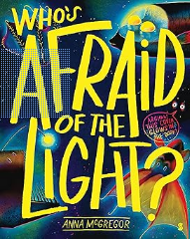 | 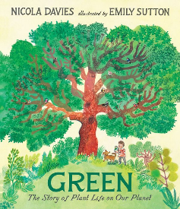 | 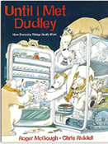 | 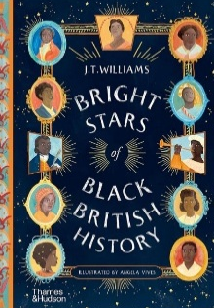 | 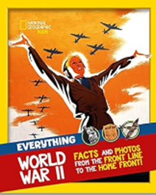
Model Text |  |  | Information leaflet | Non-chronological report about a Dragon fish | Persuasive Letter regarding deforestation | Explanation | Non-chronological report | Persuasive Letter to end rationing
Main Writing Outcome | Mark making with purpose  Fine and gross motor | Transcription – letter formation  Initial sounds and labels | Transcription  Information leaflet | Transcription  Non- Chronological | Transcription  Persuasive Letter to reduce, reuse, recycle | Transcription  Explanation text | Transcription  Non-chronological report | Transcription  Persuasive letter
Audience and purpose |  | Christmas & Diwali cards  Labelling animals | Creating information leaflets about a car to inform parents. | Informing a deep-sea diver about Fergus the Gulper Eel. | To persuade Battle primary students to make more of an effort to reduce, reuse, recycle. | Writing an explanation text for the school newsletter. | Writing a non-chronological report to inform year 4 pupils about modern Black figures | Writing a persuasive letter to allow evacuees to return home after war for the school newsletter.
Lexile Score  Key Concepts  (See KOs for more detail Y1 – 6) | n/a L  Traditional tales  Patterns in stories | n/a L  Language and vocabulary | Unknown L  Types of cars  Related vocab. | AD510L  Deep Sea Creatures  Ambitious vocabulary | Unknown L  Life and Planet Forms  Related and ambitious vocab. | Unknown L  Non-fiction  Features of explanation  Imagination | Unknown L  Symbolic and allegorical meaning  Related vocab. | Unknown L  War and world leaders  Cause and effect  Related vocab.
Main Class Reader(s) | 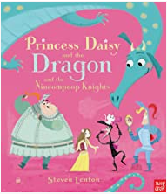  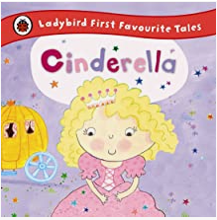  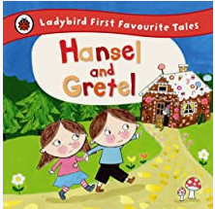 | 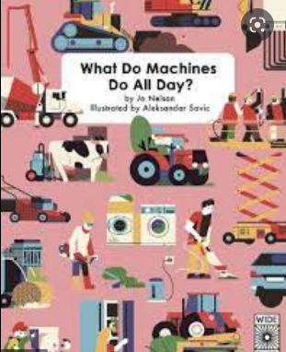  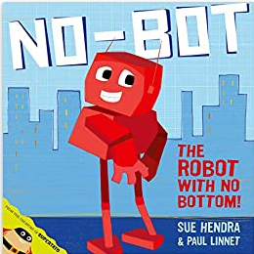  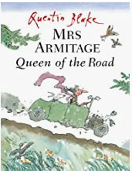 | 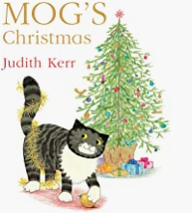  And other books in the series/books by Judith Kerr | 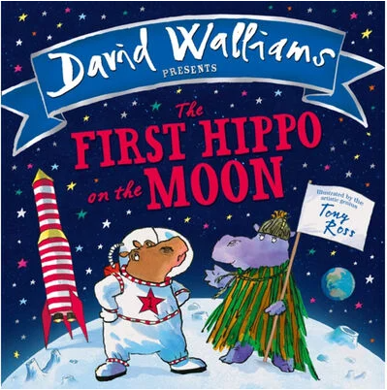  And other picture books by David Walliams | 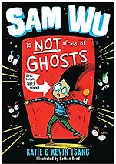  Diversity & inclusion | 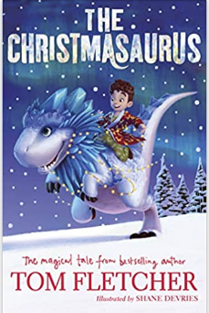  Diversity and inclusion | 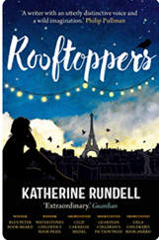  Book by the same author | 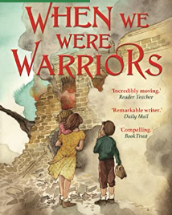  Books by the same author
Guided Reading  (extracts, articles, online articles, non-fiction books, poetry) | RWI Phonics and fluency |  |  | De-codable text RWI | Bill’s New Frock Anne Fine  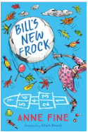  Challenging stereotypes | A River  Marc Martin  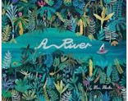  Language | War Horse Michael Morpurgo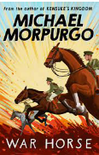  Comparing first person animal accounts | Letters from WWI  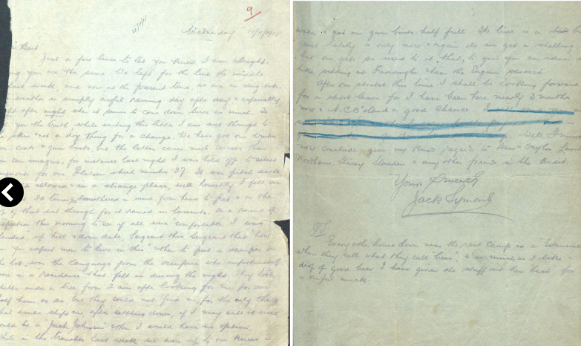  Non-fiction  Recount
 |  |  |  | De-codable text RWI | Mousakka Recipe  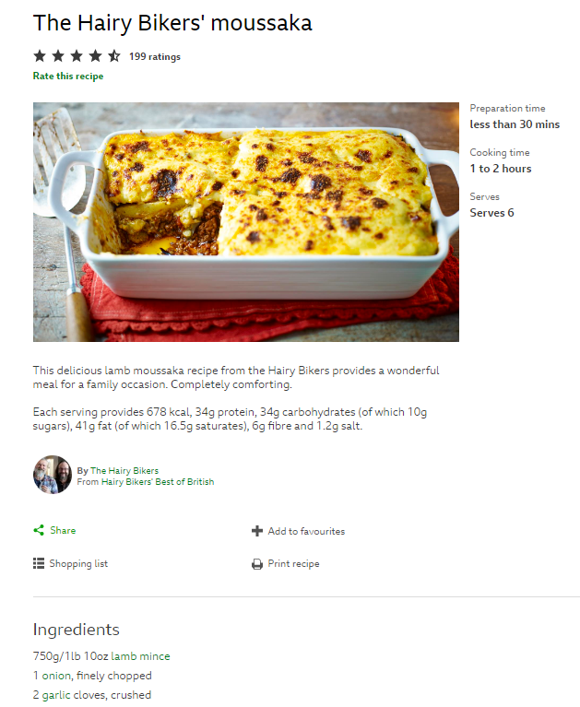  Non-fiction - instructions | Why Do People Wear Poppies?  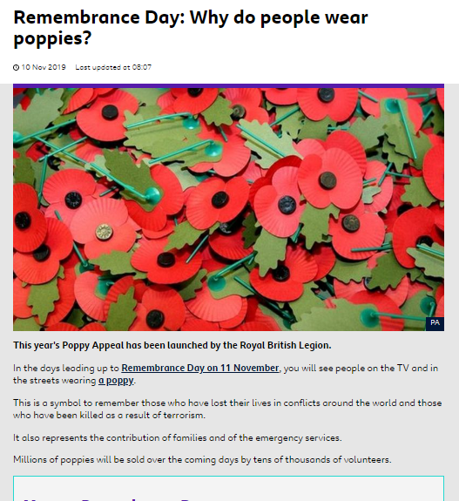  Topical | How Parachutes Work  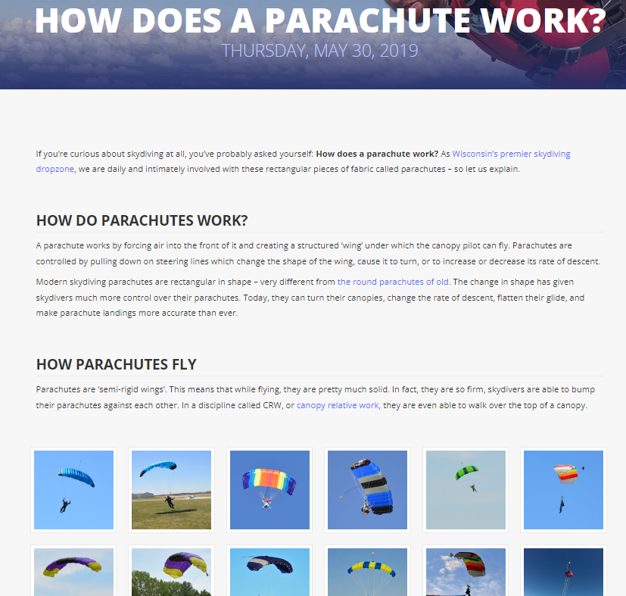  Non-fiction -explanation | The Sentry WWI Poem  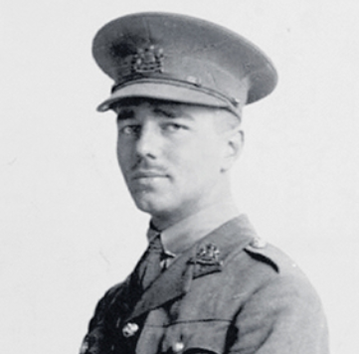  Poetry
 |  |  |  | De-codable text RWI | The Sound Collector  Roger McGough  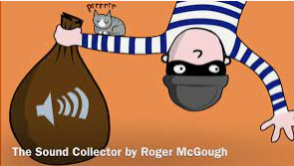  Poetry | My Shadow Robert Louis Stevenson  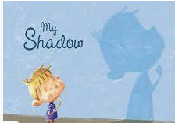  Poetry | Sia Lyrics  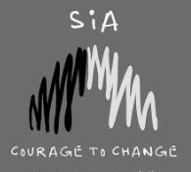  Poetry | Anne Frank  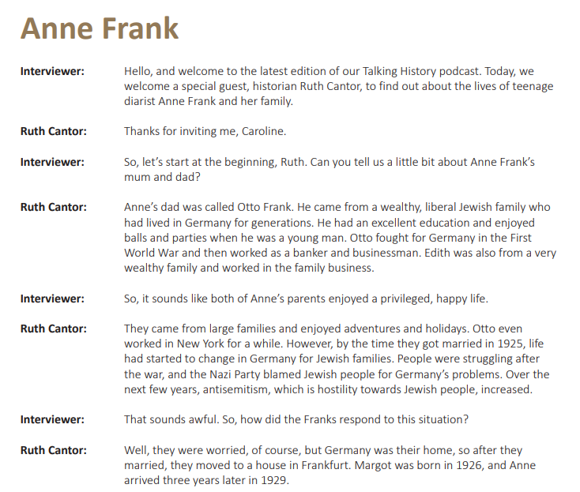  Podcast
 |  |  |  | De-codable text RWI | Stig of the Dump  Clive King  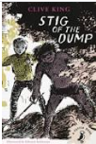  Classic | Alice’s Adventures in Wonderland  Lewis Carroll  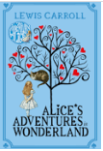  Classic | The Hobbit  J.R.R. Tolkien  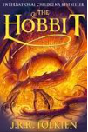  Classic | Post-War World  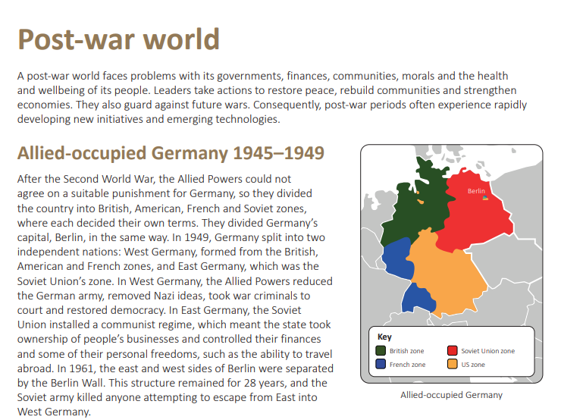  Non-fiction  History link
 |  |  |  | De-codable text RWI | Louis Braille Biography  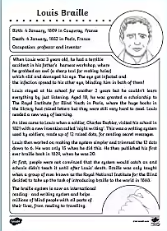  Non-fiction  Diversity & inclusion | Frida Kahlo  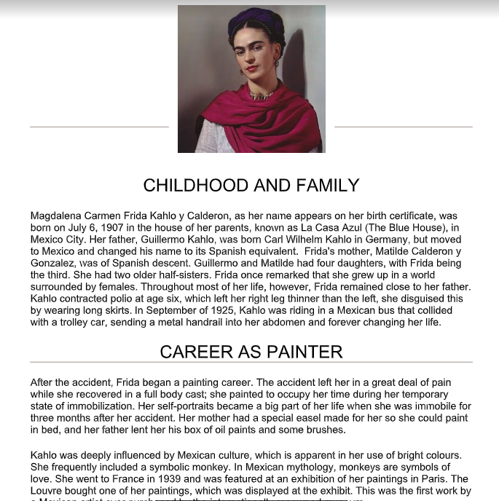  Non-fiction  Diversity & inclusion | Mae Jemison    Non-fiction  Diversity & inclusion | Hitler’s Canary  Sandy Toksvig  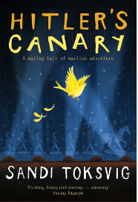  Fiction  Compare to model text
 |  |  |  | De-codable text RWI | Masai and I  Nancy Carpenter  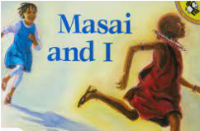  Diversity & inclusion | The Demon Headmaster Gillian Cross  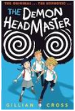 | Cogheart  Peter Bunzl  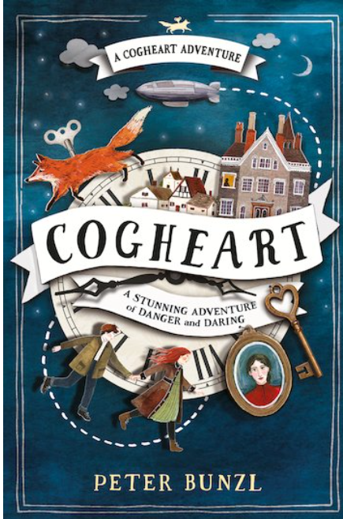 | VE Day Poem  

