2nd March 2020

Dear Parents/Carers,

I am sure, like me, you were delighted to hear that all children can return to school from 8th March. It has been an extremely challenging time for everyone and I thank you for your commitment to keeping everyone safe and supporting your children to continue with their education. I am so grateful to everyone for their resilience, patience, kindness and encouragement.

You will see that much of this letter is the same as the plans that were put in place for September. This is because the need for caution is still very much a requirement of us all at this time; the guidance is stricter than it was for September, even though we are all desperate for some sort of normality. The aim of this letter is to provide you with a detailed overview of plans for the return to school on Monday 8th March, linking it to the guidance and routines that will be in place to allow for full re-opening. I know that this contains a lot of information, however please take the time to look at it carefully so that our whole community is as informed as well as it can be.

It is important that all families read this letter very carefully even if your children have been in school because some of the current arrangements are changing.

Whilst we all hope that the plans being put in place will all take effect, it is prudent and wise to say that they are in part conditional to any announcements or further advice received from the government.

- Attendance from Monday 8th March for all children will be expected: the guidance makes it clear it is not a choice. This means that we are looking forward to seeing everyone back in school. Only critically vulnerable children are exempt and this will only be authorized on production of a medical exemption letter.

- There is an expectation that the whole community complies with government restrictions put in place for everyone’s safety and with Public Health England advice and that everyone engages with NHS Track and Trace.

- Children will be encouraged, but not expected, to socially distance from each other. The children are allowed to sit next to each other at desks. From Yrs. 2-6, desks will be arranged so that they will all be facing towards the front, sitting in rows, as directed in the DFE guidance. There will be, where possible, social distancing in place between pupils and staff and between staff themselves.
- Routines around hygiene, including hand washing, cleaning and toilet hygiene will be at an enhanced level and strictly adhered to.

- Classrooms will be well ventilated by opening windows and doors.

- All children will be expected to wear school uniform.

- The government guidance is continuing to require us to ensure all pupils receive a high quality education with a curriculum that is “broad and ambitious”.

- On our return, our priority is that we make time to resettle the children. We will be reinforcing familiar routines and expectations and assessing where children are with their learning in order to then help them make excellent progress, whatever their starting point.

Groupings/Bubbles
Bubble 1 Nursery (Seuss)
Bubble 2 Year 1 (Andersen & Kipling)
Bubble 3 Year 2 (Barrie & Nesbit)
Bubble 4 Year 3 (Carroll & Dickens)
Bubble 5 Year 4 (Blyton & Lewis)
Bubble 6 Year 5 (Shakespeare & Zephaniah)
Bubble 7 Year 6 (Austen & Bronte)

Breakfast Club and After School Club will be operating as usual and in line with government guidance. Booking needs to be made in the normal way as numbers are restricted.

School lunches will revert back to booking on Parentpay.

We would ask all parents and carers to support the school with our measures by preparing your child as much as possible in advance; this can be done by discussing the measures or practising them at home.

Practise CATCH IT! BIN IT! KILL IT! This means catch a cough or sneeze in a tissue over the mouth and nose, throw this straight into the bin and then wash hands with soap and water. Please could we ask you to provide your child with a small packet of tissues each so they can all do this safely.

- Practise good hand hygiene – washing hands for 20 seconds.

- Practise self-care and dressing – staff will not be able to help your child as they would normally be allowed to, although of course we won’t let any children feel worried or upset if they can’t quite manage!

- Practise unscrewing and tightening water bottle lids.

- Practise opening the regular items of food you wish to put in your child’s packed lunch.

- Apply sun cream and hand cream before the school day if required.

Arrivals, Drop Offs and Pick Ups – this is as it was in September except for year 6


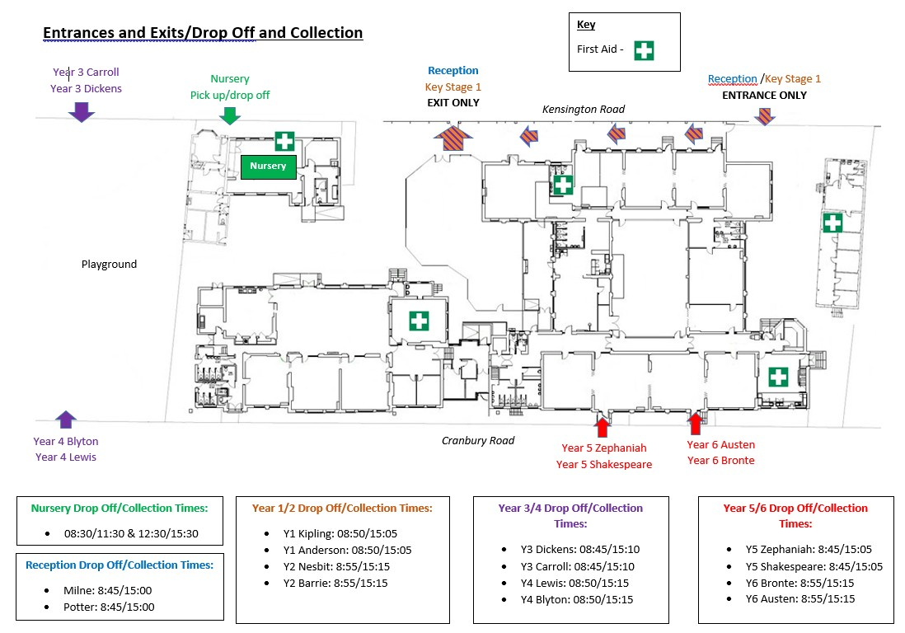
Year 5/6 Drop Off/Collection
Times:

- Y5 Zephaniah: 8:45/15:05
- Y5 Shakespeare: 8:45/15:05
- Y6 Bronte: 8:50/15:15
- Y6 Austen: 8:50/15:15
Timings

You will see the timing is very tight to allow us to ensure a full teaching day and cater for staggered starts and finishes. Please do not arrive early or late as these measures comply with Covid-19 guidance and we will not have extra adults available to manage your children at times outside of the designated ones.

If you are late arriving you will need to take your child around to the School Office and they will be able to register there. If you are late collecting you will need to go to the Art room.

What your child should bring to school
- Packed lunch if needed (including a healthy snack of fruit, vegetables or cereal bars for break).
- Named water bottle.
- Reading book.
- P.E. kit
- Warm coat
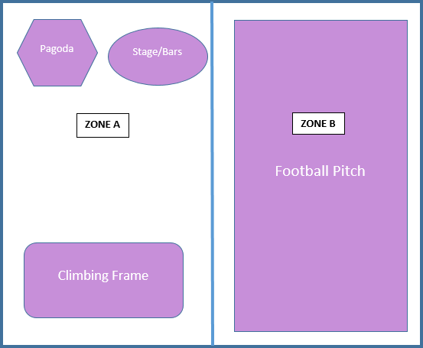
Lunchtimes – this is as it was in September

Top Hall

Bubble | Eating Time | Playground
Early Years | 11:30-12:00 (incl dedicated space for Nursery/30hrs) | 12:00-12:30
Year 1 | 12:00-12:30 | 11:30-12:00
Year 4 | 12:30-13:00 | 13:00-13:30 (Zone B)
Year 3 | 13:00-13:30 | 12:30-13:00 (Zone A)

Lower Hall

Bubble | Eating Time | Playground/Park time
Year 2 | 12:00-12:30 | 12:30-13:00 (Zone B)
Year 5 | 12:30-13:00 | 13:00-13:30
Year 6 | 13:00-13:30 | 12:30-13:00

Behavioural Expectations:

- All children need to understand and try to follow the social distancing rules in a developmentally appropriate way
- All children must stay within their ‘bubbles’ in their designated teaching and play spaces
- Children will be able to manage altered routines for the school day and follow instructions on hygiene and hand-washing
- Normal positive behaviour guidelines apply – we use a Therapeutic Thinking Approach at Battle Primary
- Where children’s dangerous behaviour puts others at risk, including at risk of viral spread, such as running out of their area, spitting or biting and where they are unwilling or unable to respond to the positive strategies used, then parents will be asked to take them home.

I apologise for the large amount of information, but I wanted to share as much as I could and reassure you that the safety of the children and staff are our first priority. I would also like to draw your attention to the two attachments to this letter and ask that you familarise yourself with them also:

- The parental flowchart for reporting a child’s illness
- The Covid-19 Risk Assessment which has been updated this month and can also be found on the school website.

I would like to take this opportunity again to thank you all for your understanding and support over the past few months as new principal. I assure you we will review our procedures regularly and keep you informed of any changes.

Warmest regards,
Louise Burridge
Principal

